

CHILDREN AND FAMILY COURT ADVISORY AND SUPPORT SERVICE

Paper for the Board meeting scheduled 9 March 2007

PERFORMANCE REPORT

1 AIM AND PURPOSE

1.1 To provide the Board with an update overview of the operational service position as at 31 December 2006.

2 ACTION FOR THE BOARD

2.1 This report is for information and discussion only.

3 RECOMMENDATION

3.1 For the Board to note the report and key issues.

4 KEY STRATEGIC ISSUES FOR THE BOARD TO CONSIDER

Key Performance Indicators | Target / Norm | Performance | Year to Date
1 – S31 allocations within 2 days | 70% | ☹  | 56.0%
2 – Total allocations within 28 days | 98% | 😐  | 94.7%
3 – Public unallocated | 3% | ☺  | 2.9%
4 – DR’s with full/partial agreement | 55% to 65% |  | 59.4%
5 – DR’s referred for S7 | 35% to 45% |  | 17.9%
6 – Service user diversity | 80% | ☹  | 54.0%
7 – Appraisals completed in 12 mo. | 100% | ☹  | 50.7%
8 – Sickness Absence | 4% | 😐  | 4.2%
A – Private unallocated <10 weeks | 4% | 😐  | 4.6%

Sherry Malik Allison Calvert

Corporate Director, Strategy & Performance Corporate MIS Manager

Andrew Thorpe
MIS Data Analyst

KPI 1 – 70% of allocations during the month for Section 31 cases (care and supervision) should be within 2 working days from receipt of request (receipt day counted as nought).
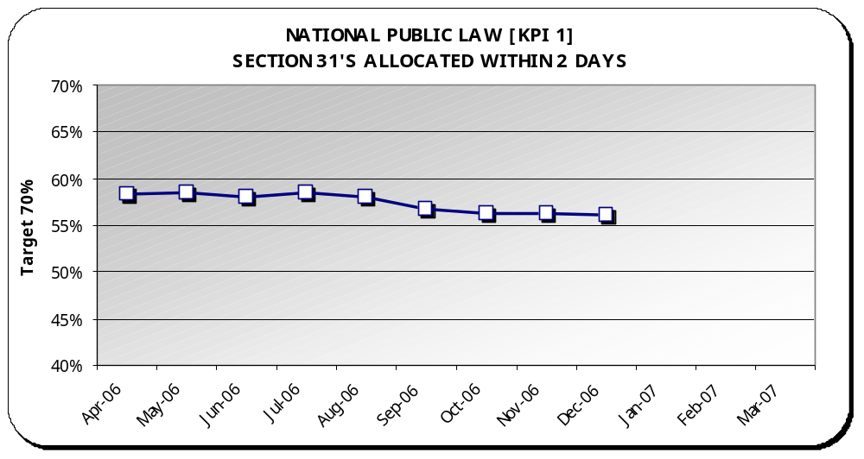 | Target | Performance | Year to Date
 | 70% | ☹ | 56.0%

Analysis
Graph - Year to date performance has fallen slightly from 56.3% to 56.0% as at the end of December.

Best Performance – East Midlands (92.8%)

Regional Hotspots – Greater London (20.7%), North East (32.3%), West Midlands (39.5%), South East (44.8%) and Yorks and Humberside (58.3%).

Performance Changes –
-  Eastern moved from red (59%) to amber (60.5%)

Comparison (April through December) - Last year’s performance was 48.5%.

NB: This graph shows the performance each month as a year to date percentage. Year to date percentages are used to build a picture of performance as the year progresses. This is also the most accurate picture given that the Case Management System allows for timely reporting of amendments.

KPI 2 – At least 98% of all public law allocations each month for all case types should be within 28 working days from receipt of request.
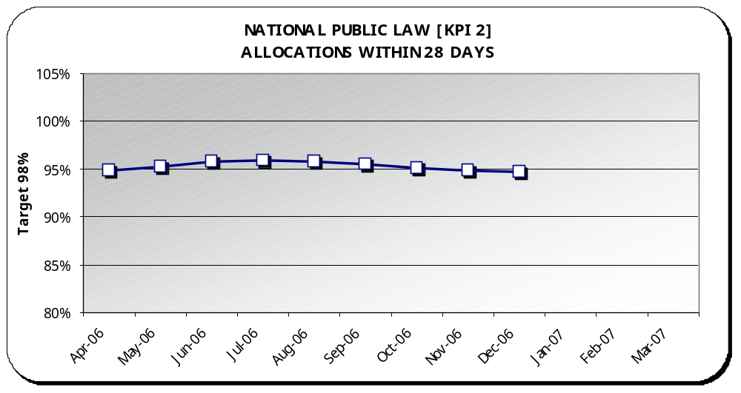 | Target | Performance | Year to Date
 | 98% | 😐 | 94.7%

Analysis
Graph - Year to date performance has fallen slightly from 94.9% to 94.7% as at the end of December.

Best Performance – Southern (99.6%)

Regional Hotspots - North East (75.6%) and West Midlands (86.5%).

No Performance Changes

Comparison (April through December) - Last year’s performance was 90.8%.

NB: This graph shows the performance each month as a year to date percentage. Year to date percentages are used to build a picture of performance as the year progresses. This is also the most accurate picture given that the Case Management System allows for timely reporting of amendments.

KPI 3 – No more than 3% of the public law workload should remain unallocated at month end.
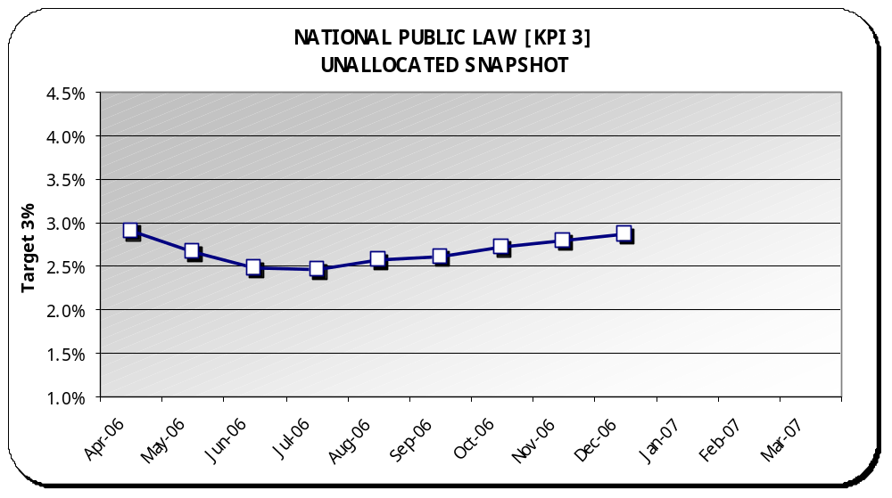 | Target | Performance | Year to Date
 | 3% | ☺ | 2.9%

Analysis
Graph - Year to date performance has fallen from 2.7% to 2.9% as at the end of December.

Best Performance – South West (0.5%)

Regional Hotspots - North East (9.3%) and West Midlands (4%)

Performance Changes –
-  South East moved from amber (3.1%) to green (3%)
-  West Midlands moved from amber (3.7%) to red (4%)

Comparison (April through December) – Last year’s performance was 2.8%.

Backlog – Unallocated cases are continuing to rise, however, backlog is still being sustained against the target. December’s backlog was 388 cases.

NB: This graph shows the performance each month as a year to date percentage. Year to date percentages are used to build a picture of performance as the year progresses. This is also the most accurate picture given that the Case Management System allows for timely reporting of amendments.
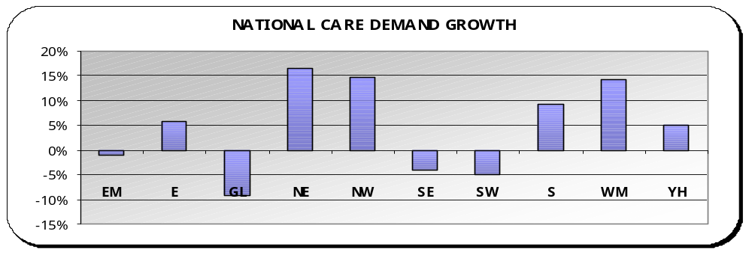 | Public Law demand - In comparing this year to date to the same period last year, Public Law care requests are up 4.1%. Six regions are showing increases in demand to date compared to the same period last year.  Overall total Public Law requests, when including all types of proceedings, were down 1.9% comparing the same period.  Adoption requests were down 26.6% in same period.
KPI 4 – Percentage of dispute resolutions (including extended dispute resolutions) resulting in full or partial agreement.
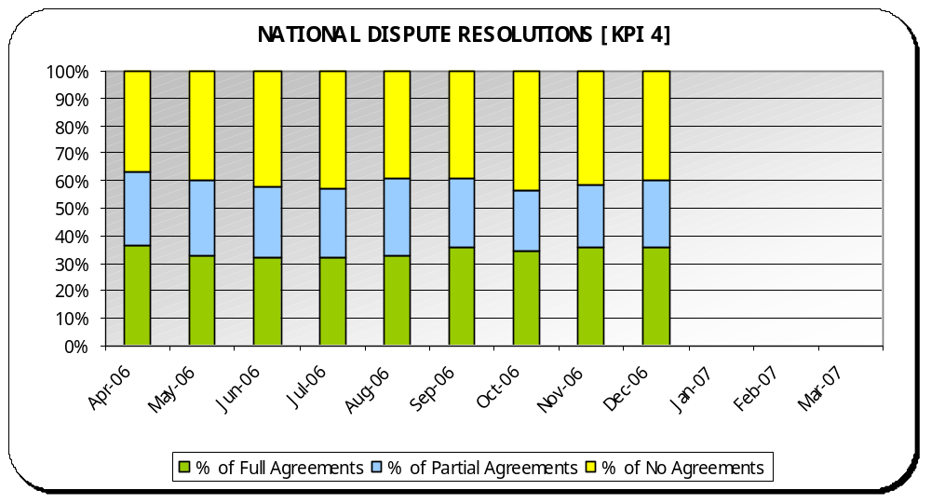 | Norm | Performance | Year to Date
 | 55% to 65% |  | 59.4%

Analysis
Graph - Year to date performance has increased slightly from 59.3% to 59.4% as at the end of December.

Max – Eastern (73.7%)

Min –South East (53.4%)

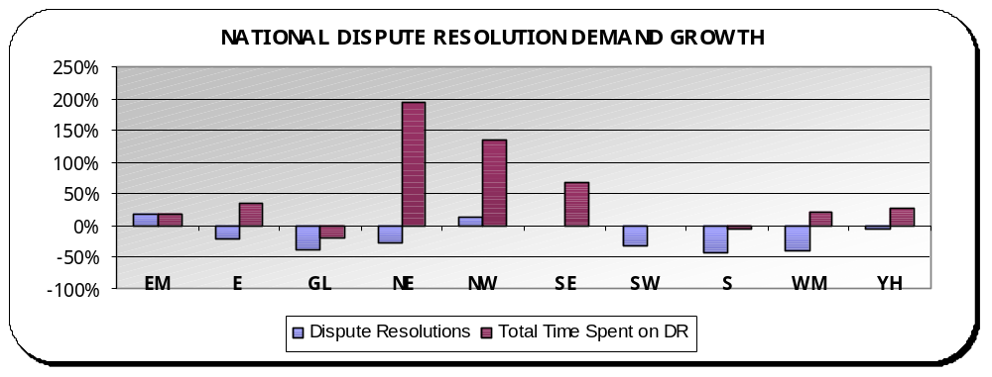 | Dispute Resolutions: In comparing this year to date to the same period last year, Dispute Resolutions are down 19.3%. Three regions are showing increases.  Time spent on Dispute Resolutions are up 12,093 hours compared to the same period last year. This equates to a 38.9% increase with eight regions showing increases.

KPI 5 – Percentage of Section 8’s referred for dispute resolution that are then, referred for a Section 7.
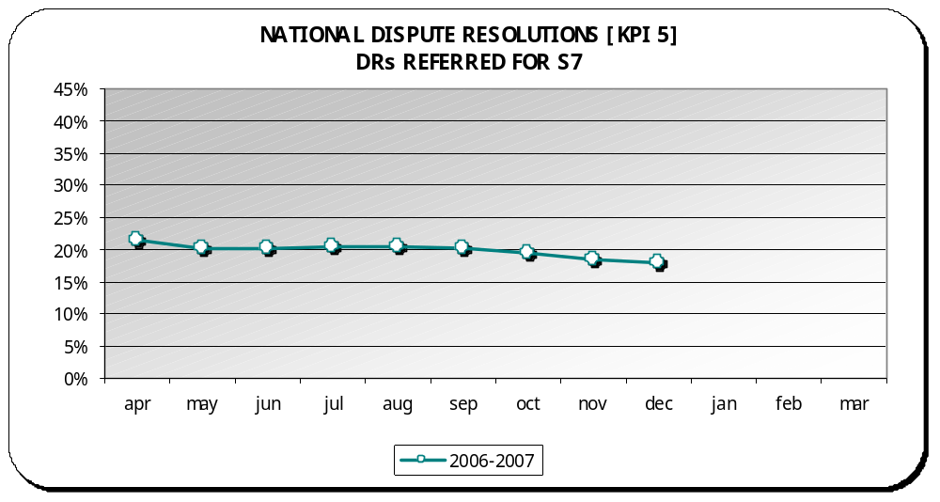 | Norm | Performance | Year to Date
 | 35% to 45% |  | 17.9%

Analysis
Graph - Year to date performance has improved slightly from 18.5% to 17.9% as at the end of December.

Max – South East (26.3%)

Min – Eastern (9.9%)

NB: This graph shows the performance each month as a year to date percentage. Year to date percentages are used to build a picture of performance as the year progresses. This is also the most accurate picture given that the Case Management System allows for timely reporting of amendments.

NB: Rollout of CMS teams this year – due to the changing work of private law and the subsequent changes required for CMS, KPI 5 for CMS teams is not currently measured and will be unavailable until a new report is completed by our service provider. Once completed, figures will be updated.

KPI 6 – 100% diversity monitoring forms returned for all service users by year-end.
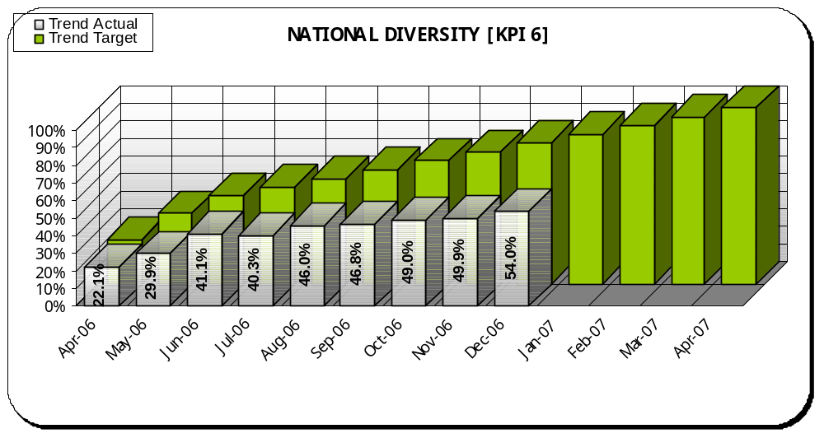 | Interim Target | Performance | Year to Date
 | 80% | ☹ | 54%

Analysis
Graph - Year to date performance has improved from 49.8% to 54% as at the end of December.

Best Performance – North East (65.2%)

Regional Hotspots – All regions are hotspots: Greater London (32.7%), West Midlands (41.9%), North West (42.9%), South West (51.2%), Eastern (56.4%), East Midlands (59.4%), Southern (62.3%), Yorks & Humberside (63.9%), South East (64.3%) and North East (65.2%).

No Performance Changes – interim target increase incrementally from 75% to 80% for December

NB: This graph shows the performance each month as a year to date percentage against a progressive monthly interim target. Year to date percentages are used to build a picture of performance as the year progresses. This is also the most accurate picture given that the Case Management System allows for timely reporting of amendments.

Diversity: Since the introduction of a new KPI in April of 100% forms returned for all parties and children in new cases by the end of 2006-2007, all regions have been concentrating on improving their returns, and many have action plans in place. While there is a continuing upward trend, nationally we are still not meeting the interim monthly target and this gap is widening. 7.1% of teams are meeting the stretch interim target of 80% for December and another 8.6% of teams were on-target with more than 70% returned.

KPI 7 – 100% appraisals completed for all staff within a 12-month rolling period.
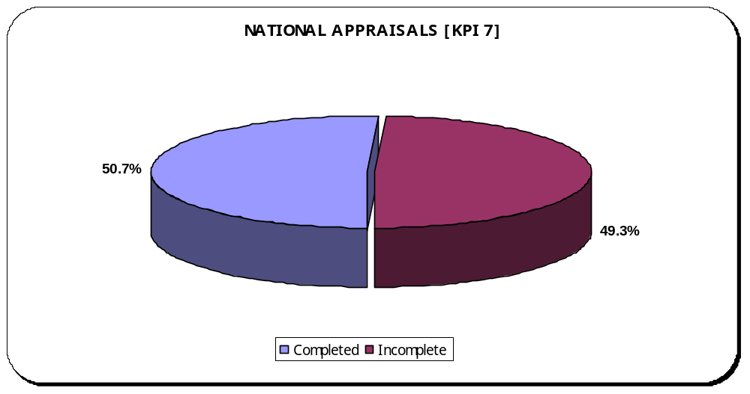 | Target | Performance | Year to Date
 | 100% | ☹ | 50.7%

Analysis
Graph - Year to date performance has improved slightly from 50.6% to 50.7% as at the end of December.

Best Performance – North East (95.4%)

Regional Hotspots –South East (22.9%), Greater London (25.2%), National Office including Legal Services (28.6%), South West (30.1%), West Midlands (32.4%), Southern (39.3%), East Midlands (43.8%), Eastern (44.7%), North West (67.5%) and Yorks and Humberside (84.1%).

Performance Changes – No changes for December

Appraisals: This graph shows the performance as a year to date percentage. The Quarter 3 regional performance monitoring is currently underway. This KPI and surrounding issues will be scrutinized where performance is low.

KPI 8 – Sickness absence rate of no more than 4% should be maintained.
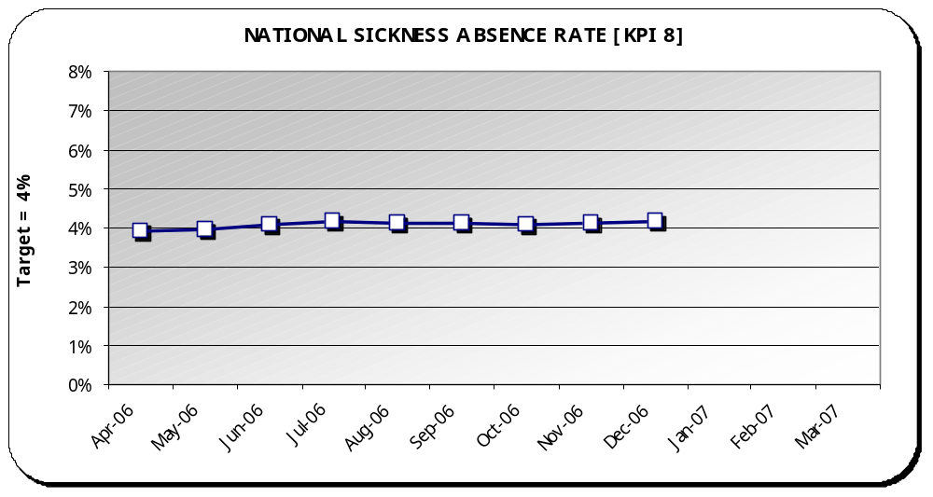 | Target | Performance | Year to Date
 | 4% | 😐 | 4.2%

Analysis
Graph –Year to date performance has fallen slightly from 4.1% to 4.2% as at the end of December.

Best Performance – South West (2%)

Regional Hotspots – Southern (5.9%) and North West (5.8%).

Performance Changes – No changes for December

Workforce: This graph shows the performance each month as a year to date percentage. Nationally, sickness absence at 4.2% is on-target to meet 4%. Much of the sickness in the regional hotspots is down to long term sickness of a small number of staff and plans are in hand to address this through occupational health. Increasing demand can also place pressure on a regions capacity. There is still a missing capacity of 35 WTE (whole time equivalent) for FCA’s and 4.2 WTE for Service Managers nationally.

Private Law Summary
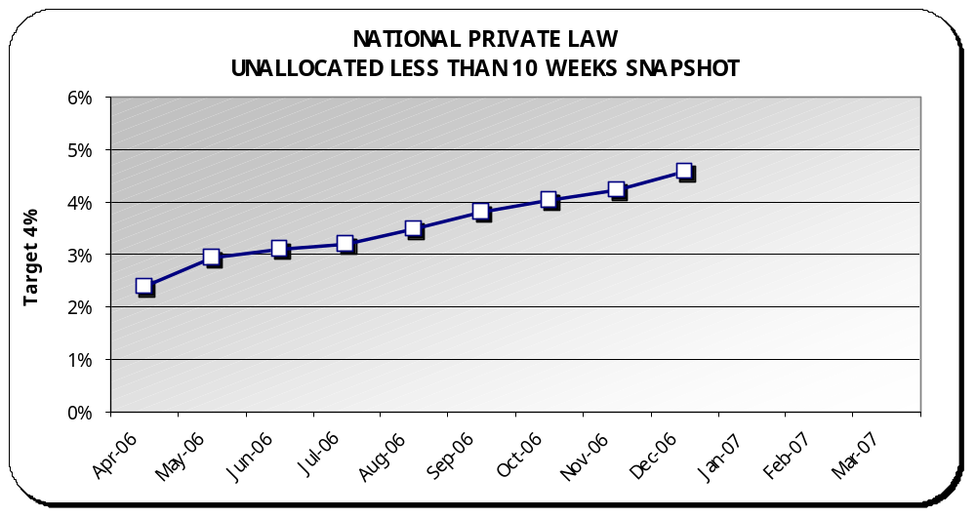 | Target | Performance | Year to Date
 | 4% | 😐 | 4.6%

Analysis
Graph - Year to date performance has fallen from 4.2% to 4.6% as at the end of December.

Best Performance – East Midlands (0.8%)

Regional Hotspots – South East (9.1%), West Midlands (6.4%), North East (6.1%) and North West (5.4%).

Performance Changes –
-  Greater London moved from green (3.9%) to amber (4.8%)

Comparison (April through December) – Last year’s performance was 3.2%.

Backlog - private law unallocated reports less than 10 weeks have been steadily increasing. December’s backlog less than 10 weeks was 627 reports. Total unallocated backlog was 1,476 reports which is in-line with previous years.

NB: The graph above shows the performance each month as a year to date percentage. Year to date percentages are used to build a picture of performance as the year progresses. This is also the most accurate picture given that the Case Management System allows for up to the minute reporting of changes.

Private Law Summary continued
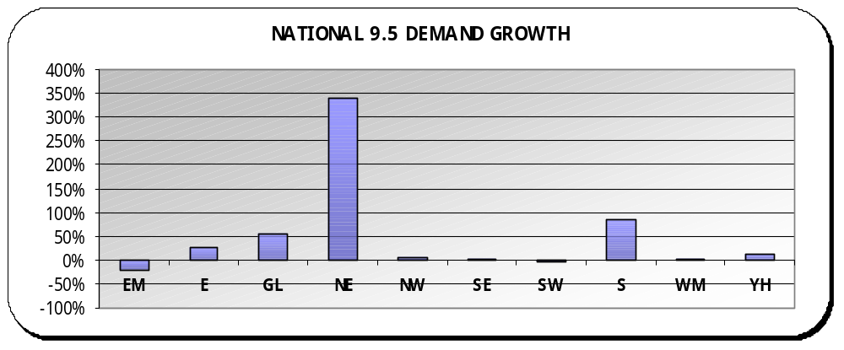 | Private Law demand - Comparing this year to date to last year, Rule 9.5 cases are up 16.8% (131 cases) compared to last year, with eight regions showing an increase.  NB - North East’s increase relates to an increase of 34 cases.  Overall, total Private Law report requests were down nationally 11.7%. All regions are reflecting this downward trend in total private law reports except South East who have an increase of 2.7%.  Family Assistance Orders - In comparing this year to date to the previous year, FAO’s are down 26% (129 orders). Yorks & Humberside is the only region with an increase (29 orders).
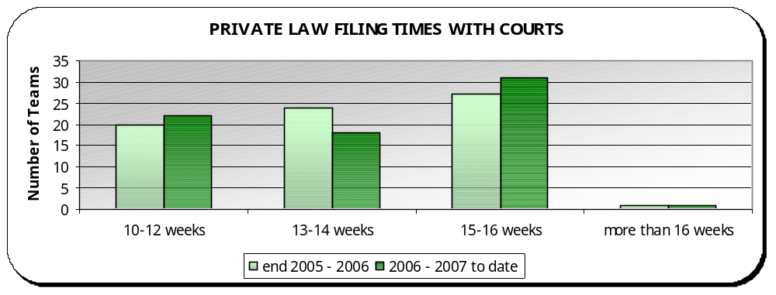 | Private Law Court Filing Times – 31.9% ☺ of teams meet the standard filing time of 10–12 weeks, 23.6% 😐 of teams are on target to meet the standard with 13–14 weeks, 41.7% of teams have filing times of 15–16 weeks ☹ and 2.8% of teams are filing more than 16 weeks ☹ (2 teams). These are Slough (17 weeks) and Lancaster (+17 weeks).  Performance Changes – (in weeks)  -  Cornwall (from 16 to 14)  -  Basingstoke (from 14 to 12)  -  Oxford (from 13 to 12)  -  Leeds (from 14 to 16)

Finance Summary
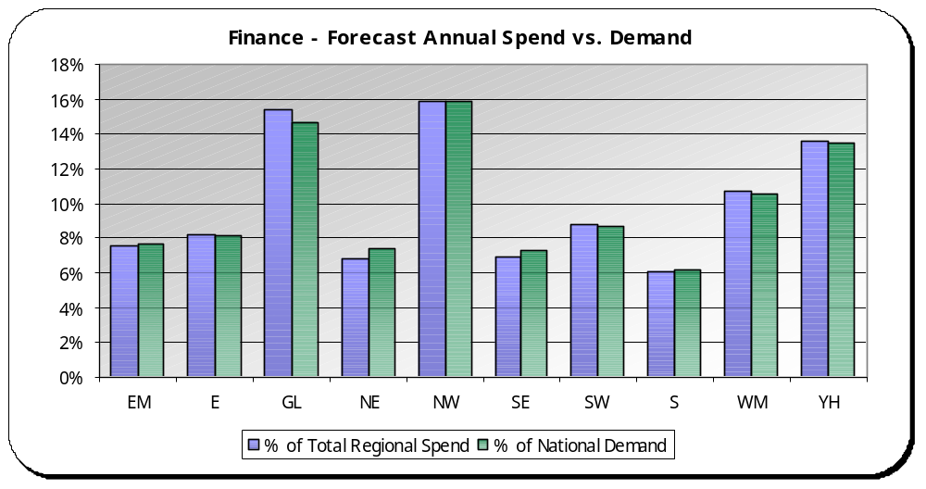 | Analysis  Overall, there is a strong correlation between resource use and activity with no real significant outliers.  Max – North East is using a smaller percentage of resources compared to their share of demand activity.  Min – Greater London is using a greater percentage of resources compared to their share of demand activity.

NB: Forecasts are produced quarterly and activity is calculated monthly based on a rolling 12-month period.

Finance: This graph compares each region’s use of resources compared to their demand activity.

The percentage of spend is calculated by taking the regions quarter 3 forecast spend as a percentage of total regional forecast spend at quarter 3. The percentage of demand activity is calculated by taking the regions total rolling 12-month demand activity (as at December 2006) as a percentage of total national demand activity (as at December 2006).

It is expected that these two percentages should equal.

